Huntingdon Borough Council Meeting
Tuesday, October 19, 2021

The Huntingdon Borough Council meeting was held in the Borough Council room, 530 Washington Street, Huntingdon, PA 16652.
Guest present were John Parks, Gary Cramer, Chuck Streightiff, Pauline Streightiff, Fred Hess, Tom Streightiff, Jack Hale, Mike Smith, Emily Loose, Jim Hudack, Kathy Hudack, Jay Brouse, Shelly Franks, Dan Varner, Dennis Banks, Lonnie Woomer, Bill Walters, Donna Walters, John Cook, Sheriff Jeff Leonard, Corporal Moyer, Trouper Beal, Shannon Gummo, Rufus Brenneman, Jeff Buckley, Karl Lang and Robert Ritchey.
Police Officers present were Brent Kagarise, Justin Franks, Shaun McCready and Corey Stuller.
The Huntingdon Borough Council meeting was called to order by President Johnathan Hyde at 7:30 PM.
The Invocation was given by Mayor David Wessels.
The Pledge of Allegiance was presented by President Johnathan Hyde.
Roll Call was taken by Borough Secretary Richard King and the following members were present:
President Johnathan Hyde
Vice-President Sean Steeg
Councilman David Quarry
Councilman David Fortson
Councilwoman Dee Dee Brown
Councilman James Bair
Councilman Terry Green
Mayor David Wessels
Engineer Ryan Calhoun in place of Kevin Nester
Solicitor Richard Wilson
Chief of Police Charles Streightiff
Borough Manager Chris Stevens
Borough Secretary Richard King
President Johnathan Hyde welcomed the guest present and asked for their comments.
James Hudack of 1312 Washington Street was there to talk about the letter they have received from the Code Enforcement Officer on their sidewalk after they had seal coated it stating it must be in concrete. James Hudack said that seal coating is a preventive maintenance. James Hudack is requesting that Borough Council reconsider this letter of having to replace their sidewalk with concrete.
James Hudack mentioned that if the intent of replacing all asphalt sidewalks with concrete that he would suggest using some of the Community Development Block Grant allocation. James said that the residents on this block would be considered the presumed beneficiaries and would meet the LMI criteria of 51%.
Mike Smith of 315 11th Street was there to question about the borough taking over the recycling and was told the borough would do this all in one day.
Borough Manager Chris Stevens said yes the borough was taking over the recycling but we were going to go by the street sweeping / maintenance schedule that is already in place.
President Johnathan Hyde called on the review and act on the minutes of the following meetings:
Borough Council Meeting – September 21, 2021
Maintenance Committee Meeting – October 5, 2021
Water & Sewer Committee Meeting – October 5, 2021
Public Safety Committee Meeting – October 5, 2021
Community Development Committee Meeting – October 5, 2021
Parks, Recreation & Public Property Committee Meeting – October 5, 2021
Administrative Committee Meeting – October 5, 2021
A motion was made by Councilman David Quarry to approve the above minutes and second was made by Councilwomen Dee Dee Brown. Motion Carried.
President Johnathan Hyde called for a motion to approve payment of the October 2021 bills.
A motion was made by Councilman David Quarry to approve payment of the October 2021 bills and second was made by Councilman David Fortson. Motion Carried.
President Johnathan Hyde called for a motion to approve the September 2021 Financial Statements for all borough accounts.
A motion was made by Councilman David Quarry to approve the September 2021 Financial Statements for all borough accounts and second was made by Councilman David Fortson. Motion Carried.
President Johnathan Hyde called on the Committee reports.
President Johnathan Hyde called on the Maintenance report.
Chairman Terry Green had nothing to report.
President Johnathan Hyde called on the Water & Sewer report.
Chairman Sean Steeg said that 4th Street CSO project is almost complete and HRI needs to finish the punch list.
President Johnathan Hyde called on the Public Safety report.
Chairman James Bair reported the Public Safety committee recommends a motion to approve & sign the Civil Service Commission new revised Rules & Regulations.
A motion was made by Councilman David Quarry to approve & sign the Civil Service Commission new revised Rules & Regulations and second was made by Vice-President Sean Steeg. Motion Carried.
Chairman James Bair thanked all the first responders. James said there were 77 calls in September and 48 of these were pumping out basements in the borough. James said the year to date calls was 328.
President Johnathan Hyde called on the Community Development Committee report.
Chairwoman Dee Dee Brown thanks everyone for their participation on the Bryan Park Dedications, and the donors, sponsors and those that helped. Dee Dee thanked Borough Manager Chris Stevens for his work and said he turned a disaster into a beautiful park.
President Johnathan Hyde called on the Parks, Recreation & Public Property Committee report.
Chairman David Fortson had nothing to report.
President Johnathan Hyde called on the Administrative Committee report.
Chairman David Quarry reported the Administrative committee recommends a motion to approve Ordinance No. 2021-968 Amending the Huntingdon Borough Code §10-501, ET SEQ., to restrict the use of excessively loud fireworks and classify the improper or dangerous use of fireworks as a public nuisance and providing for penalties for violations.
A motion was made by Councilman James Bair to approve Ordinance No. 2021-968 Amending the Huntingdon Borough Code §10-501, ET SEQ., to restrict the use of excessively loud fireworks and classify the improper or dangerous use of fireworks as a public nuisance and providing for penalties for violations and second was made by Vice-President Sean Steeg. Motion Carried.
Chairman David Quarry reported the Administrative committee recommends a motion to approve Ordinance No. 2021-969 Amending Chapter 13, Part 3 of the Huntingdon Borough Code to regulate food vehicles as a transient retail business.
A motion was made by Councilman James Bair to approve Ordinance No. 2021-969 Amending Chapter 13, Part 3 of the Huntingdon Borough Code to regulate food vehicles as a transient retail business and second was made by Councilwomen Dee Dee Brown. Motion Carried.
Executive Session was called for at 7:43 to discuss personnel issues.
Executive Session ended at 7:49 with the following action to be taken: Borough Council was briefed on the final results of the police officer hiring process, and a conditional job offer was made to the selected candidate and if the necessary conditions are met, the new police officer will be sworn in at the December public meeting.
President Johnathan Hyde called on any old business.
There was nothing reported under old business.
President Johnathan Hyde called on any new business.
There was nothing reported under new business.
President Johnathan Hyde called on the President’s report.
President Johnathan Hyde reminded everyone that the November 2, 2021 Committee meeting will be moved to November 9, 2021, due to November 2nd being the Municipal Election day.
President Johnathan Hyde thanked all the borough employees and was blessed with the borough having good employee’s.
President Johnathan Hyde called on the Chief of Police report.
Chief of Police Charles Streightiff thanked the Huntingdon Moose Lodge #223 for their donations and said these donations were appreciated.
President Johnathan Hyde called on the Mayor’s report.
Mayor David Wessels reported he had done 2 weddings and has accessed the usual fee.
Mayor David Wessels said he can speak enough on Bryan Park.
Mayor David Wessels said that Trick or Treat night is Sunday, October 31, 2021 from 6:00 to 8:00 PM and reminded everyone to be aware of small children.
Mayor David Wessels said the Halloween Parade is scheduled for Monday, October 25, 2021, starting at 7:00 PM.
President Johnathan Hyde called on the Engineer’s report.
Ryan Calhoun said the Certificate of Completion has been signed for the CDBG Curb cuts, the NPDES permit has been uploaded, site visits were done on October 7th and reports will be coming, Risk & Resilience Assessment has been certified, and the Emergency Response plan is on schedule to be completed and submitted by the end of the year, the SCADA laptop is being loaded and GHD is working on the permits for the amphitheater.
President Johnathan Hyde called on the Solicitor’s report.
Solicitor Richard Wilson had nothing to report.
President Johnathan Hyde called on the Borough Manager’s report.
Chris Stevens said Maintenance is working on the Solar Street Lights, then will be moving to the soft boat launch and then to the amphitheater.
President Johnathan Hyde called on any other business.
Mayor David Wessels called on Charles T. Streightiff to swear him in as Chief of Police.
Borough Manager Chris Stevens read Charles T. Streightiff Bio.
Mayor David Wessels told Charles T. Streightiff to repeat after him the Oath of Office.
I, Charles T. Streightiff, duly appointed by Huntingdon Borough Council to the position of Chief of Police, do hereby swear that I will support, obey, and defend the Constitution of the United States and The Constitution of the Commonwealth of Pennsylvania and I will fairly enforce the laws of this nation, state and borough and that I will discharge the duties of my office with fidelity.
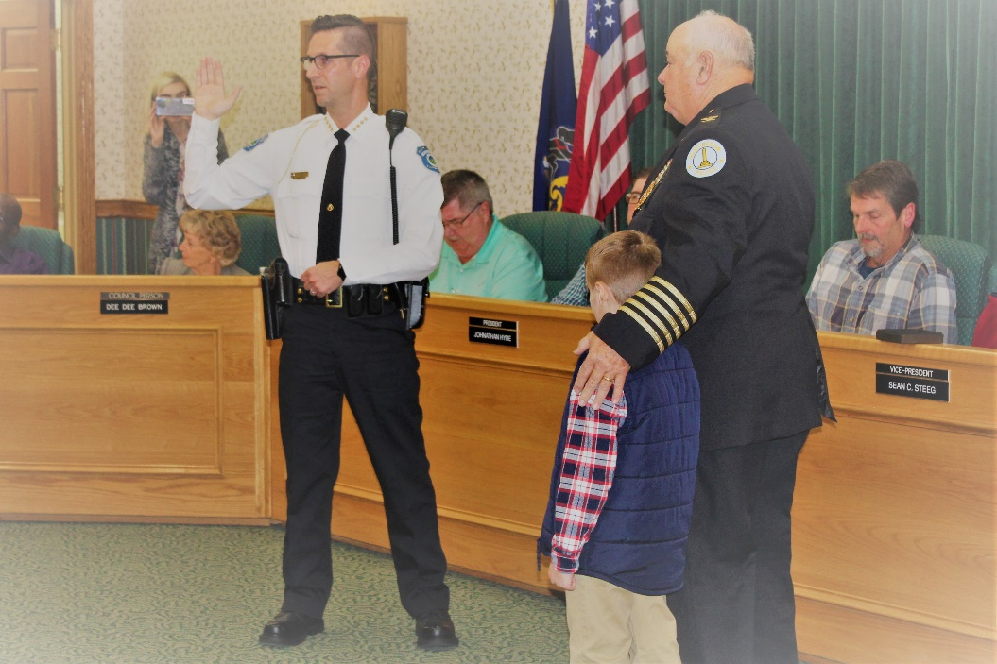
Former Chief of Police, Charles A. Streightiff, then pinned Charles T. Streightiff, Chief of Police Badge on him.
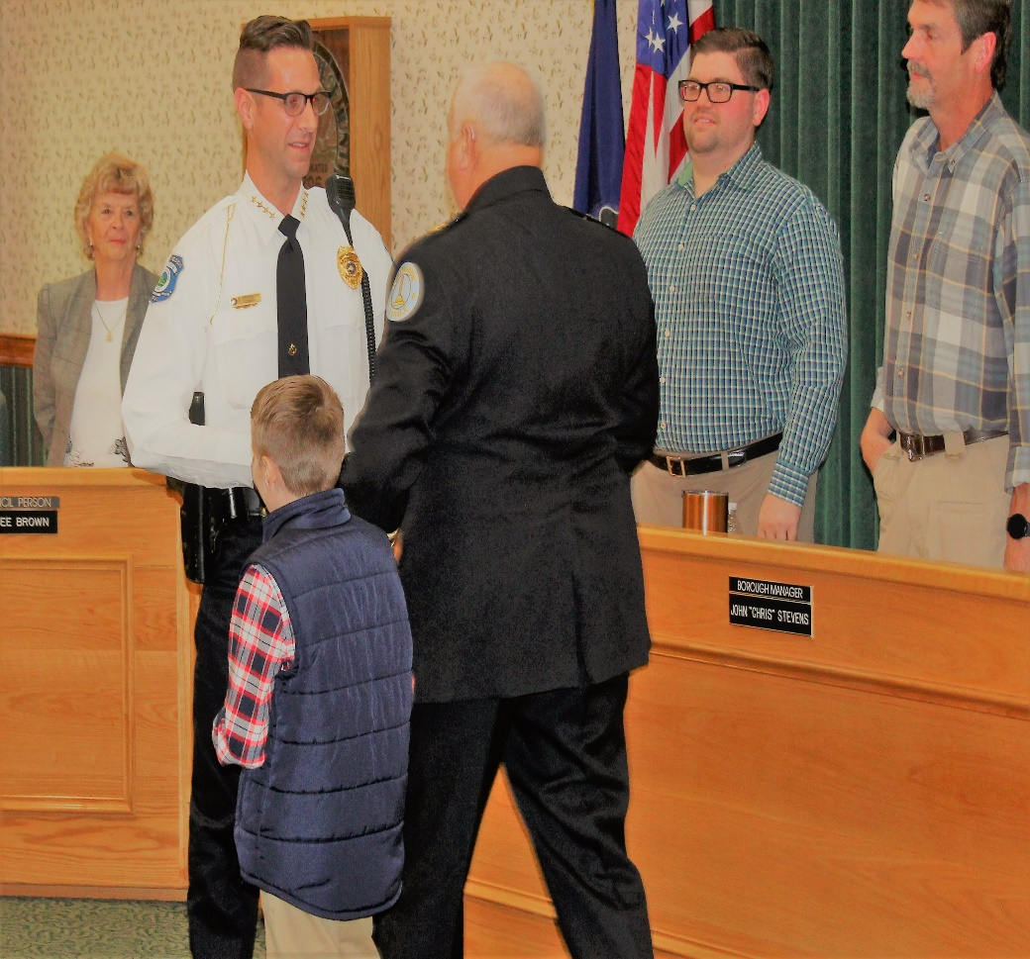
Chief of Police Charles T. Streightiff then gave his speech.
Good Evening!
I want to first and foremost thank everyone in attendance this evening. I am truly honored and grateful to stand before you all as the Chief of Police of the Huntingdon Borough Police Department. Thank you to the Huntingdon Borough Council for having the faith in me to serve in this capacity.
As I stand here and look upon those in attendance, I have to mention and honor our former Chiefs’ of Police:
Daniel Varner
Charles A Streightiff
Rufus Brenneman
Jeff Buckley
I have worked for each one of these Administrators, and have known each one for the majority of my life. This Department would not be what it is, without the leadership bestowed by each of these retired Chiefs of Police. I also have to acknowledge our Borough Manager, and retired HPD Corporal Chris Stevens. I have learned from all of you, and because of the leadership and guidance over years, you all have shaped and molded me into the Officer I am today.
I want to thank my family…my wife Kristen, my children…Alexis and Aiden, and my parents…Chuck and Pauline Streightiff. My in-laws…John and Carol Cook. Your support means everything to me. Without it, I would not have been able, nor could I continue doing this job.
To my other family…HPD. You all know that every decision that I make is what I believe is in the best interest of the department and this borough. I have said this many times, to many people…I have worked for and with many agencies at various levels. This borough can rest assured that we have a very qualified and dedicated department. I am extremely proud of each of you, and as a team, we will continue to build upon the departmental foundations and standards that have been set by those who wore the uniforms before us.
To the other agencies in attendance this evening…thank you. I look forward to working with each of you, and continuing to foster our professional relationships and endeavors.
Now, this night is just about me. We have three other officers to be recognized. This is a monumental occasion for any officer in their career, and again, I am honored to be able to be in a position to promote these three officers.
Chief Charles T. Streightiff called upon Officer Brent Kagarise to promote him to Detective/Criminal Investigator.
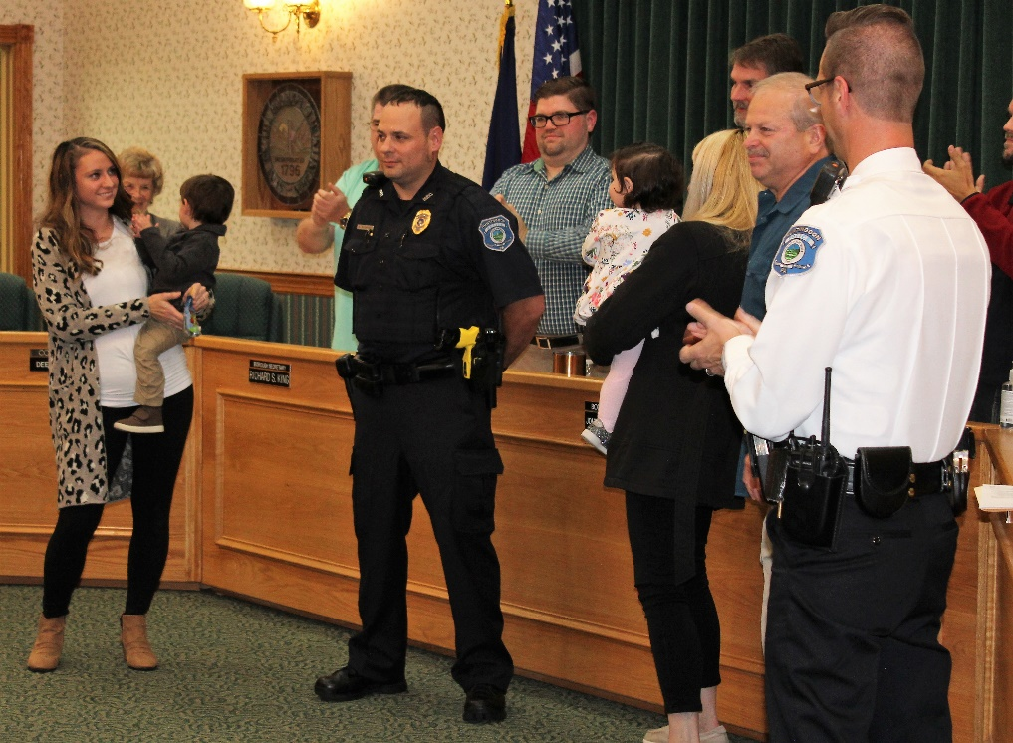
Chief Rowdy Kagarise of the Williamsburg Police Department and father of Detective/Criminal Investigator Brent Kagarise pinned his badge on him.
Chief of Police Charles T. Streightiff called on Officer Justin Franks to promote him to Corporal.
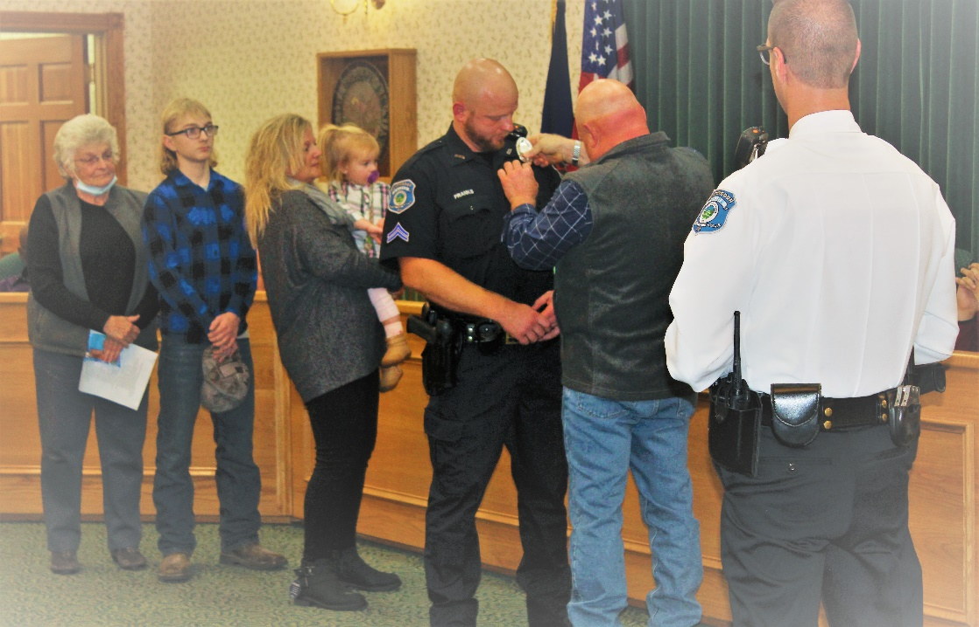
Michael Franks, father of Justin Franks pinned his badge on him.
Chief of Police Charles T. Streightiff called on Officer Shaun McCready to promote him to Corporal.
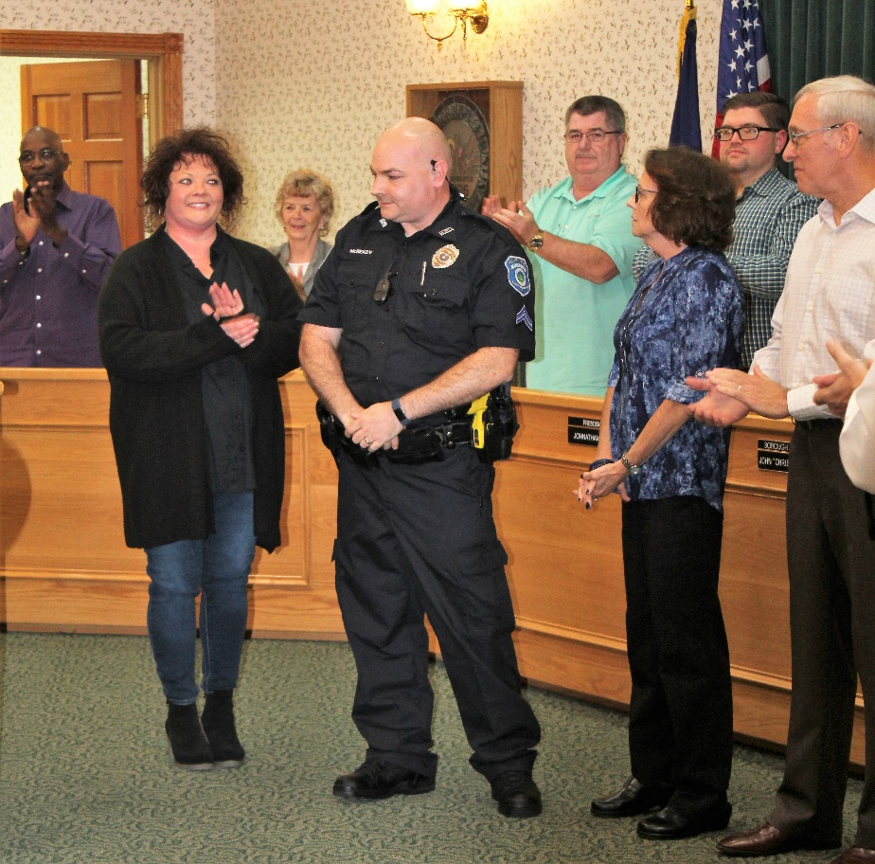
Paula McCready, mother of Officer Shaun McCready pinned his badge on him.
President Johnathan Hyde called for a motion to adjourn.
A motion was made to adjourn the Borough Council meeting at 8:14 PM by Councilman David Quarry and second was made by Councilwomen Dee Dee Brown.
Minutes submitted by,
Richard S. King
Borough Secretary

