Huntingdon Borough Maintenance Committee Meeting Minutes
Tuesday, April 2, 2024

The Huntingdon Borough Maintenance Committee meeting was held in the Borough Conference Room, 530 Washington Street, Huntingdon, PA 16652.
The guest present were Jennifer Clark, Gary Cramer and Joseph Thompson.
The members present were President James Bair, Vice-President David Fortson, Councilman Robert Jackson, Councilman Terry Green, Councilwoman Jennifer Powell, Borough Engineer Andy Glitzer, Maintenance Foreman Travis Gutshall, Mayor Thomas Yoder, Borough Manager Chris Stevens, and Borough Secretary Richard King.
Chairman Terry Green called the Maintenance Committee meeting to order at 2:00 PM.
Chairman Terry Green recognized the guest present and asked for their comments.
There were no comments made by the guest present.
Chairman Terry Green called on the Maintenance Foreman’s report.
Travis Gutshall said that if there no questions on his report, that he had nothing else.
Chairman Terry Green called on the Borough Engineer’s report.
Andy Glitzer said that he had several items to bring up and asked Borough Manager Chris Stevens if he wanted to talk about the McGraw Development.
Chris Stevens brought up the development on the screen, and said that the water line North of Warm Springs needs replaced on Cold Springs Road.
Chris Stevens said we are looking at running a water line from the development down to Blair Avenue and tie this in.
Chris Stevens said by doing this, we will be drawing water from the Flag Pole Hill tank instead of the Highlands tank.
Chris Stevens said that we will need easements either from the Wawrose property or Thomas’s property and we will be crossing Muddy Run.
Chris Stevens said they intend to put a pump station in and pump the sewage to the line near Cold Springs Road, but we cannot get our JetVac Truck in there. Chris said we need to run a sewer line to Blair Avenue also.
Chris Stevens said that GHD will be drawing all of this up.
Andy Glitzer said about the wetland determination, and that by running the sewer line down, that this will save them money, by not installing a pumping station and force main.
Chris Stevens said that we could work with CES Engineers in doing this.
Andy Glitzer said that the NPDES Stormwater permit could take up to a year to receive it.
Andy Glitzer then said do we want to talk about the 15th Street radius.
Chris Stevens then placed this on the screen for everyone to see.
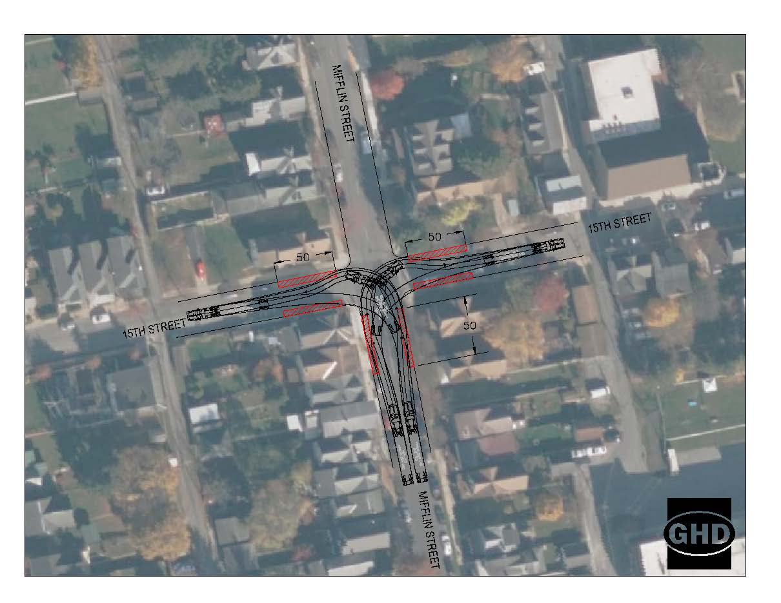
Chris Stevens said that this will add parking to the southern side of 15th Street between Mifflin Street and Moore Street.
Chris Stevens said that it would take 50 feet of both sides to be stripped or painted yellow on 15th Street and also on Mifflin Street.
Andy Glitzer said a punch list was given to KLA for the amphitheater project to do and then we will be closing this out.
Andy Glitzer said that he was going back and forth with DCNR on the restroom project and they did not like the pathway of the walkway to the restrooms.
Andy Glitzer said the grant for this was extended till 2025.
Andy Glitzer said that he does not have an update from Bruce-Merrilees for the traffic signals upgrade.
Chairman Terry Green called on the Borough Manager’s report.
Chris Stevens informed the committee that Jesse Theys from PennDOT will be coming in on May 2nd to go over the streets that we will be paving, and then we can bid this out, when he sends us the paperwork.
Chris Stevens said that in conjunction with this, that the timing, we could also bid out for the 7th Street Parking Lot project.
Chris Stevens said that we will have Brad Hollenbaugh help this year with spring cleanup.
Chairman Terry Green called on old business.
There was nothing reported under old business.
Chairman Terry Green called on new business.
Councilman Robert Jackson said there is a drainage problem in front of the brewing company, that it floods when it rains.
Maintenance Foreman Travis Gutshall said that he needs to pave his parking lot and it needs milled.
Executive Session was not called for.
After no further business, the Maintenance Committee meeting was adjourned at 2:50 PM.
Minutes submitted by,
Richard S. King
Borough Secretary

