Huntingdon Borough Council Meeting Minutes

The Huntingdon Borough Council meeting was held in the Borough Council Room, 530 Washington Street, Huntingdon, PA on Tuesday, September 16, 2025.
The guest present were Gary Cramer, Jennifer Clark, Philip Lott, Betty Quarry, David Quarry, Allison McClain and Jamie Roberts.
Huntingdon Borough Police Officers present were Phillip Miller, Dorian Conrad, Izac Benson, Shaun McCready and Brooke Colledge.
President James Bair called the Borough Council meeting to order at 7:00 PM.
The invocation was given by Councilwoman Jennifer Powell.
The Pledge of Allegiance was presented by President James Bair.
Roll call was taken, and the following members were present, President James Bair, Vice-President David Fortson, Councilman Robert Jackson, Councilwoman DeeDee Brown, Councilman Terry Green, Councilwoman Jennifer Powell, Borough Solicitor Richard Wilson, Chief of Police Charles Streightiff, Borough Manager Chris Stevens and Borough Secretary Richard King.
President James Bair said that we need to add a resolution to the agenda, which needs to be executed for the sale of the Weaver Park Softball Field to Juniata College, and this will come under the Administrative Committee report.
President James Bair called on the Chief of Police Charles Streightiff.
Chief Charles Streightiff said that he had several police commendations that would be given tonight.
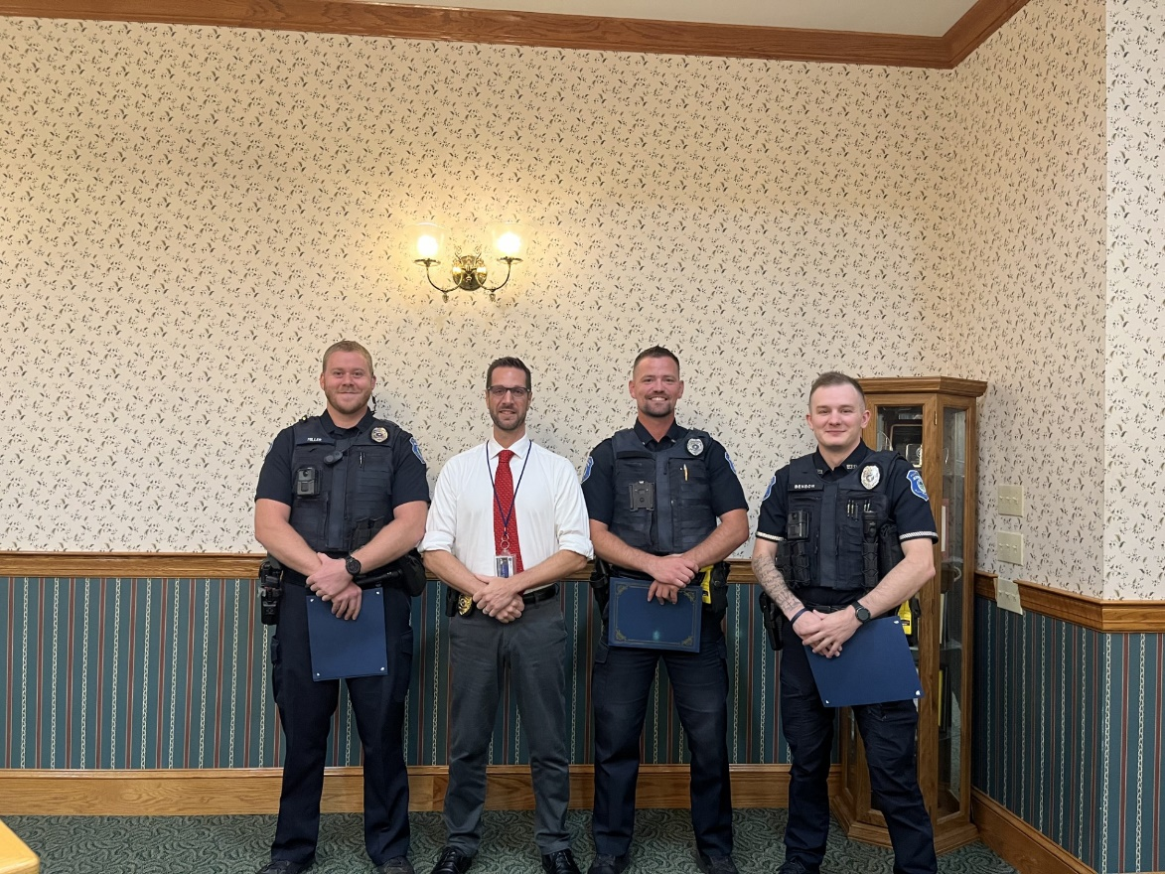
L to R: Officer Miller, Chief Streightiff, Officer Conrad & Officer Benson
Chief Charles Streightiff said the first one is given to Officer Izac Benson and Officer Phillip Miller.
Upon the recommendation of Patrol Supervisor and with the authorization of Chief of Police Charles T. Streightiff, Officers Izac Benson and Phillip Miller are hereby awarded a commendation for their exceptional work during the late hours of August 18, 2025.
On that date, through proactive patrol efforts and keen attention to detail, Officers Benson and Miller effected the arrest of a convict felon and seized two stolen firearms, narcotics, and additional contraband.
While conducting a check of a suspicious vehicle parked at a closed business, the officers located two individuals passed out inside the vehicle, one of whom was a juvenile. During the investigation, Officer Miller observed what appeared to be two knives in the pocket of the adult male occupant. For officers’ safety, he attempted to disarm the individual, at which time it was discovered that the items were in fact a concealed, fully loaded handgun with a round in the chamber. A further search revealed suspected methamphetamine and drug paraphernalia. The adult male was determined to be prohibited from possessing firearms due to a prior burglary conviction.
Officer Benson obtained consent to search the vehicle, resulting in the discovery of a second concealed firearm, suspected marijuana, additional drug paraphernalia, and ammunition. The firearms were later confirmed to be registered to a deceased male.
Demonstrating initiative beyond the initial investigation, Officer Miller located an obituary for the deceased male and was able to contact the deceased’s granddaughter. It was confirmed that the firearms had been stolen during a recent burglary at the deceased’s residence.
It is important to note that the arrested individual’s prior burglary conviction was related to an incident in which a police K-9 was killed. This underscores both the danger posed by this individual and the significance of removing these weapons from his possession. By seizing the firearms and apprehending the felon, Officers Benson and Miller prevented the very real potential for future violence, thereby protecting both the community and their fellow officers from harm.
The professionalism, initiative, and thorough investigative work demonstrated by Officers Benson and Miller reflect great credit upon themselves and this Department. Their actions are commendable and worthy of official recognition.
A copy of this commendation shall be made as a permanent part of the personnel records of Officer Izac Benson and Officer Phillip Miller.
Chief Charles Streightiff said the second one was given to Officer Dorian Conrad.
Upon the recommendation of Patrol Supervisor and with the authorization of Chief of Police Charles T. Streightiff, Officer Dorian Conrad is hereby awarded a commendation for their exceptional work on August 24, 2025.
On that date, Officer Conrad was assigned a report of a stolen mini bike, last seen on August 21, 2025. Drawing upon his knowledge of the community and his initiative to go beyond the initial report, Officer Conrad searched an area known to contain an encampment. While canvassing the location, he observed tire tracks in the dirt consistent with those of the reported stolen mini bike.
Following this lead, Officer Conrad located a mini bike that was actively running. Although it had been altered with black paint, he observed purple paint on the underside and other sections of the frame, consistent with the description of the stolen bike, which had originally been reported with a purple frame. Officer Conrad secured the vehicle and made contact with a male subject in the vicinity who claimed ownership.
The subject provided several conflicting statements regarding how the bike had been obtained. The rightful owner later positively identified the recovered vehicle, and Officer Conrad successfully concluded the case with a felony arrest.
Through his proactive work, keen observations, and sound investigative tactics, Officer Conrad not only recovered stolen property but also effected the arrest of a felon, thereby preventing further loss and strengthening community trust. His initiative and thoroughness reflect great credit upon himself and this Department.
His actions are commendable and worthy of official recognition.
A copy of this commendation shall be made a permanent part of the personnel record of Officer Conrad.
Chief Charles Streightiff said the third one was given to Officer Phillip Miller as a lifesaving commendation.
In recognition of your courage, quick response and decisive actions on August 24, 2025, which directly saved the life of a suicidal female threating to jump from the Penn Street Bridge.
Upon locating the individual, you immediately engaged her in conversation in an effort to calm her and gain her trust. When she attempted to climb over the bridge railing, you reacted without hesitation, physically preventing her from jumping and ensuring her safety.
Following the rescue, you remained steadfast in your duty of care, transporting her safely to the hospital, staying with her during the registration process, and offering support until she was admitted into treatment.
Your actions exemplify the highest traditions of law enforcement – valor, professionalism, and dedication to the preservation of life. Through your efforts, you brought honor to yourself, the Huntingdon Borough Police Department and the community you so faithfully serve.
Chief Charles Streightiff then thanked the Huntingdon Borough Police Department for the excellent job they do for this community.
President James Bair recognized the guest present and asked for their comments.
Phil Lott of 401 7th Street, with a business at 623 Washington Street, was there to talk about the last festivity that was held. Phil said there was a food truck in front of his store, and this had hurt his business.
Borough Manager Chris Stevens said that you had the first spot free and you did not place a table or tent in this area.
Borough Manager Chris Stevens said that you were rude and mean to a vendor, and they said they will not be returning.
Phil Lott said this town is very important to him.
Borough Manager Chris Stevens said that we tried to get the merchants together for a meeting and this has failed.
Borough Manager Chris Stevens said if you want, we can have a meeting with the mayor, Christa McGeary, and myself to talk about this.
President James Bair said that we try to bring people downtown to help the businesses.
Jamie Roberts of 501 Penn Street said that there is a trash can that is full, by his business, that is missed when garbage is being picked up.
Borough Manager Chris Stevens said that they should be back on schedule for picking up trash.
President James Bair said we will now review and act on the minutes of the following meetings:
- Borough Council Meeting – August 19, 2025
- Maintenance Committee Meeting – September 2, 2025
- Water & Sewer Committee Meeting – September 2, 2025
- Community Development Committee Meeting – September 2, 2025
- Public Property Committee Meeting – September 2, 2025
- Parks, Recreation & Public Property Committee Meeting – September 2, 2025
- Administrative Committee Meeting – September 2, 2025
A motion was made by Councilwoman Jennifer Powell to approve the minutes and second was made by Vice-President David Fortson. Motion Carried.
President James Bair said we will now approve the payments of the September 2025 bills.
A motion was made by Vice-President David Fortson to approve the payments of the September 2025 bills and second was made by Councilman Robert Jackson. Motion Carried.
President James Bair said we will now approve the August 2025 Financial Statements for all borough accounts.
A motion was made by Councilwoman DeeDee Brown to approve the August 2025 Financial Statements for all borough accounts and second was made by Councilman Robert Jackson. Motion Carried.
President James Bair said we will now do the Committee reports.
President James Bair called on the Maintenance Committee report.
Chairman Terry Green reported that the Maintenance Committee recommends a motion to remove Kevin Reffner from Probationary Status and to make him a full-time employee.
A motion was made by Councilwoman DeeDee Brown to remove Kevin Reffner from Probationary Status and to make him a full-time employee and second was made by Councilwoman Jennifer Powell. Motion Carried.
Chairman Terry Green reported the Maintenance Committee recommends a motion to approve the application for payment #5 from WSL Inc., in the amount of $55,775.14.
A motion was made by Vice-President David Fortson to approve the application for payment #5 from WSL., Inc., in the amount of $55,775.14 and second was made by Councilman Robert Jackson. Motion Carried.
President James Bair called on the Water & Sewer Committee report.
Chairman Robert Jackson reported the Water & Sewer Committee recommends a motion to approve and sign the Portalogic Support Agreement for the Bulk Water Station at a cost of $1,500.
A motion was made by Councilman Terry Green to approve and sign the Portalogic Support Agreement for the Bulk Water Station at a cost of $1,500 and second was made by Vice-President David Fortson. Motion Carried.
Chairman Robert Jackson said that he had wished the officers would have stayed, that he wanted to personally congratulate them.
President James Bair called on the Community Development Committee report.
Chairwoman Jennifer Powell reported the Community Development Committee recommends a motion to approve Keller Engineers as the CDBG Engineering Firm for a three-year contract to expire October 20, 2028 and to sign the contract.
A motion was made by Chairwoman DeeDee Brown to approve Keller Engineers as the CDBG Engineering Firm for a three-year contract to expire October 20, 2028 and to sign the contract and second was made by Vice-President David Fortson. Motion Carried.
President James Bair called on the Public Safety Committee report.
Chairwoman DeeDee Brown thanked Chief Streightiff for recognizing the officers for commendations.
President James Bair called on the Parks, Recreation & Public Property Committee report.
Chairman David Fortson reported that Portstown Park now has a swing set.
Chairman David Fortson said that the officers know how he feels about them.
Councilman Robert Jackson said to David Fortson, that he had talked to the kids that use the skate park, and he told them to make a list of items they would like to see there.
President James Bair called on the Administrative Committee report.
Chairman James Bair reported the Administrative Committee recommends a motion to approve Ordinance No. 2025-994, amending Chapter 15, Section 15-915 of the Code of the Borough of Huntingdon to amend the hours that on-street parking is prohibited on certain streets. The amendment shall provide that on-street parking is prohibited from 5:00 AM – 8:00 AM every Tuesday on Mifflin Street between Fifth Street and Eighth Street, and from 5:00 AM – 8:00 AM every Wednesday on Washington Street between Eight and Ninth Street.
A motion was made by Councilwoman DeeDee Brown to approve Ordinance No. 2025-994, amending Chapter 15, Section 15-915 of the Code of the Borough of Huntingdon to amend the hours that on-street parking is prohibited on certain streets. The amendment shall provide that on-street parking is prohibited from 5:00 AM – 8:00 AM every Tuesday on Mifflin Street between Fifth Street and Eighth Street, and from 5:00 AM – 8:00 AM every Wednesday on Washington Street between Eight and Ninth Street and second was made by Councilman Robert Jackson. Motion Carried.
Chairman James Bair reported the Administrative Committee recommends a motion to approve the 2026 Minimum Municipal Obligation for the Non-Uniform Pension Plan.
A motion was made by Vice-President David Fortson to approve the 2026 Minimum Municipal Obligation for the Non-Uniform Pension Plan and second was made by Councilwoman DeeDee Brown. Motion Carried.
Chairman James Bair reported the Administrative Committee recommends a motion to approve the resolution confirming the various discussions and minutes of the public meetings pertaining to the Weaver Park Softball Field. Because of numerous amounts of meetings, and the minutes of those meetings, the title insurance company for Juniata College wanted something concise that summarized the discussions and decisions of council.
A motion was made by Councilwoman Jennifer Powell to approve the resolution confirming the various discussions and minutes of the public meetings pertaining to the Weaver Park Softball Field. Because of numerous amounts of meetings, and the minutes of those meetings, the title insurance company for Juniata College wanted something concise that summarized the discussions and decisions of council and second was made by Vice-President David Fortson. Motion Carried.
Executive Session was not called for.
President James Bair called on old business.
There was nothing reported under old business.
President James Bair called on new business.
Councilman Robert Jackson asked if a business wanted to have a function, do they need a permit.
Borough Manager Chris Stevens said yes.
Councilman Robert Jackson asked what if there is a protest.
Chief Charles Streightiff said that for functions, he looks at the information and if the police department is needed then they respond.
President James Bair called on the President’s report.
President James Bair thanked all of the employees, and the Police Department, Fire Department, Ambulance Division and the 911 Center. James said they are doing an excellent job.
President James Bair called on the Borough Solicitors report.
Richard Wilson said that he had nothing to report.
President James Bair called on the Borough Managers report.
Chris Stevens said that Adam Miller is working on an RCAP grant for a water tank at Westminister.
Chris Stevens said that Jen Powell is working on a park grant
After no further business, the Borough Council meeting was adjourned at 7:32 PM.
Minutes submitted by,

Richard S King
Borough Secretary

